1.PASSPORT MANAGEMENT SYSTEM

CLASS DIAGRAM:

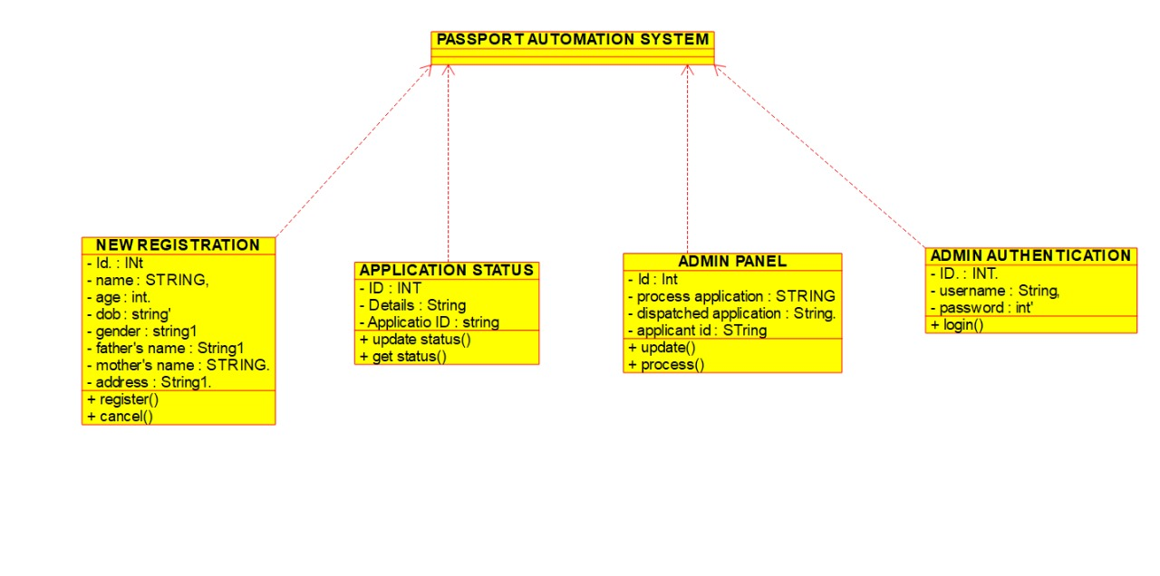

USE CASE DIAGRAM: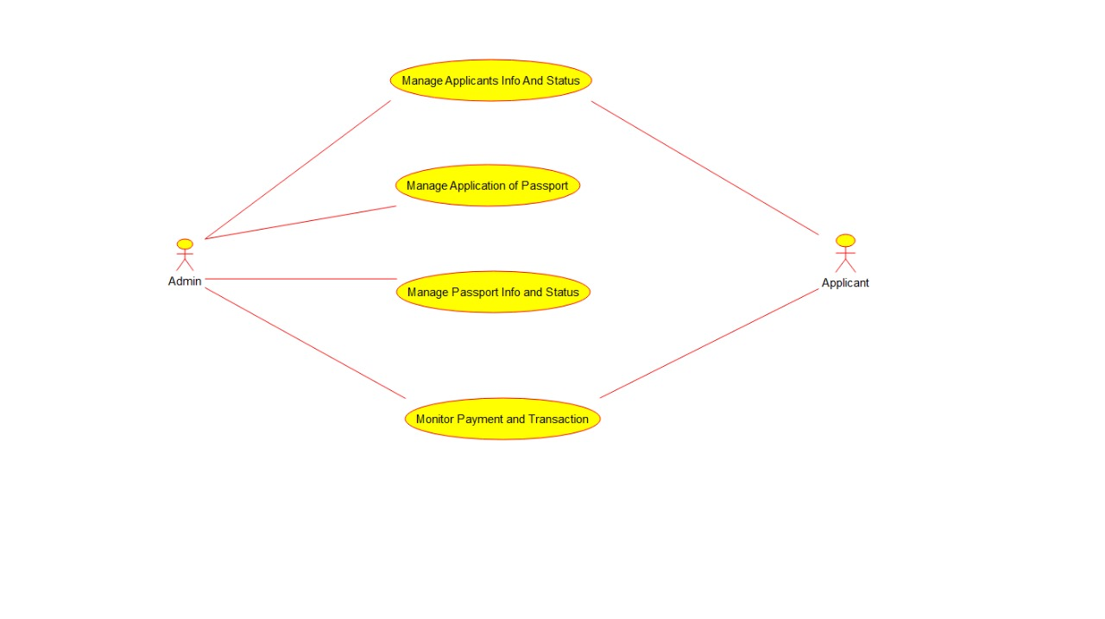

COMPONENT DIAGRAM:

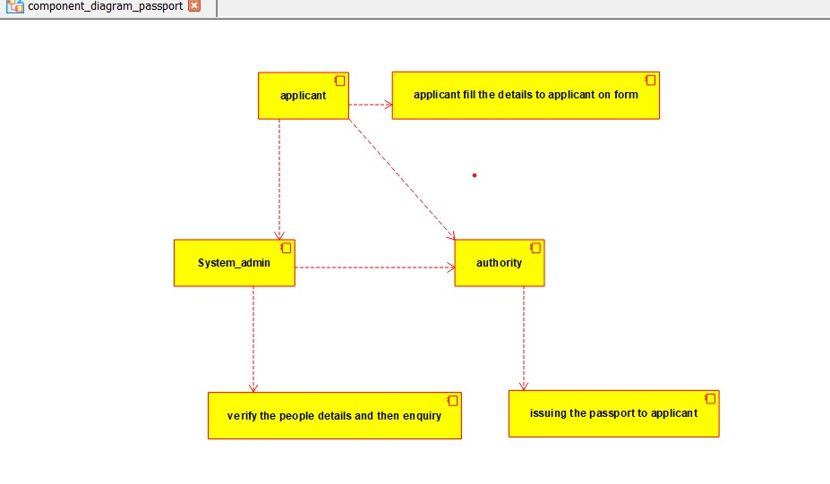

STATE CHART DIAGRAM:

